#### <Teacher> Search Question

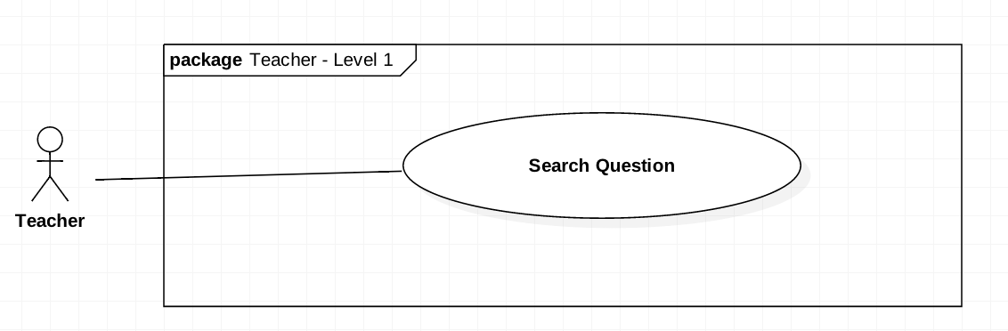

Figure 25 <Teacher> Search Question

|  |  |  |  |
| --- | --- | --- | --- |
| **USE CASE-UC_Teacher.19** | | | |
| **Use Case No.** | UC_Teacher 19 | **Use Case Version** | 2.0 |
| **Use Case Name** | Search Question | | |
| **Author** | HieuCT | | |
| **Date** | 19/11/2018 | **Priority** | Normal |
| **Actor:**   * *Teacher*   **Summary:**   * *This use case allows teacher search questions by question’s code and content* * *Support teacher can find question to edit question or remove question from question bank.*   **Goal:**   * *Teach can find the question with matching code and question content.*   **Triggers:**   * *Teacher sends search command*   **Preconditions:**   * *Login the system with teacher role.* * *User input question information (question content, question code)*   **Post Conditions:**   * *Success: Questions will be found or not be found* * *Fail: Display error messages*  1. **Main Success Scenario:**  |  |  |  | | --- | --- | --- | | **Step** | **Actor Action** | **System Response** | | *1* | *Teacher will go to list question page* | *The system will display list question information at specify page:*   * + *Code*   + *Course*   + *Mark*   + *Level* | | *1* | *Teacher input name or code in the search field* |  | | *2* | *Teacher sends a command to get questions to follow name or code in the search field* | *The system run command and show questions have been searching on the question list:*   * + *Code*   + *Course*   + *Level*   + *Mark* |  1. **Alternative Scenario:**  |  |  |  | | --- | --- | --- | | **Step** | **Actor Action** | **System Response** | | *1* | *Teacher sends a command to get questions to follow name or code in the search field* | *Show result not found on the screens* |   **Exceptions: N/A.**  **Relationships: N/A.**  **Business Rules:**   * *Get question list base on course code (A).* * *Filter all questions has content contain search value in A (B).* * *System send back B to client.* | | | |

Table 29 <Teacher> Search Question

#### <Teacher> Add Question by Form

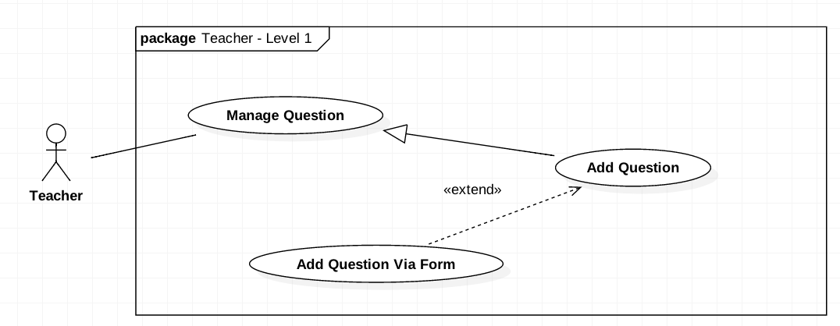

Figure 26 <Teacher> Add Question by Form

|  |  |  |  |
| --- | --- | --- | --- |
| **USE CASE-UC_Teacher.20** | | | |
| **Use Case No.** | UC_Teacher 20 | **Use Case Version** | 2.0 |
| **Use Case Name** | Add Question by Form | | |
| **Author** | HieuCT | | |
| **Date** | 19/11/2018 | **Priority** | Normal |
| **Actor:**   * 1. Teacher   **Summary:**   * 1. *This use case allows teacher to create questions by form.*   2. *Support teacher can create one question to question bank.*   **Goal:**   * 1. *Teacher can create one question manually.*   **Triggers:**   * 1. *Teacher send an create command.*   **Preconditions:**   * 1. *Teacher sends create question command*   **Post Conditions:**   * 1. *Success: Questions will be added.*   2. *Fail: Questions will not be added. Show error message*  1. **Main Success Scenario:**  |  |  |  | | --- | --- | --- | | **Step** | **Actor Action** | **System Response** | | *1* | *Teacher fill the form* | *The system requires teacher to input:*   * + *Chapter*   + *Level*   + *Mark*   + *Question Content*   + *Options* | | *2* | *Teacher send a save command to save the questions locally* |  | | *3* | *Teacher send a send command add question.* | *The system will run command and question and comeback to question list.*  *[Exception]* |   **Exception:**   |  |  |  | | --- | --- | --- | | **No** | **Cause** | **System Response** | | *1* | *Teacher not fill full question info* | *Show message to fill full form.* | | *2* | *Teacher not choose write answer for question.* | *Show message require answer* |  1. **Alternative Scenario:**  |  |  |  | | --- | --- | --- | | **Step** | **Actor Action** | **System Response** | | *1* | *Teacher add question with content matching >80% question already in database* | *Show warning may question already in database and confirm continuous to add or cancel action.* |   **Relationships: Add Question**  **Business Rules:**   * + - *Teacher fill question form (A).*     - *A has format:*  |  |  |  |  |  |  | | --- | --- | --- | --- | --- | --- | | Content | Options | Mark | Level | Chapters | Learning outcomes |  * + - *Add A to question list.* | | | |

Table 30 <TEACHER> ADD QUESTION BY FORM